Red Hat JBoss BPM Suite 6
Rewards Demo
(Use case: HR process - Human Task integration with BPM)

Eric D. Schabell
JBoss Technology Evangelist (Integration & BPM)
Table of Contents
Introduction 2
Setup and Configuration 2
Installation 2
JBoss Developer Studio Configuration 4
Running the Demo 4
JBoss BPM Suite Business Central 4
Administration Perspective 4
Project Authoring Perspective 5
Web Process Designer 5
Deploy project 6
Data Modeler 6
Form Modeler 7
Running the demo 9

Introduction
This is a JBoss BPM Suite demo application setup guide for the Rewards Demo. The setup will create a fully installed and configured JBoss BPM Suite environment so that you can demo the project in all the available BPM components.

This project demo was created to show the creation and integration of human tasks using the provided tooling into a business process.

The demo centers around a simulated company that provides a process for approving or rejecting awards for its employees. This process is called the Rewards process, anyone in the company can submit a reward for an employee by submitting the initial form when the process is started.

There is a human task to be completed by the manager role (this is the HR teams role), used solely to review the submitted reward for acceptance or rejection. If accepted, there will be a note placed in the employees personnel file (you can view it in the server log), and then an email will be sent to the employee notifying them of the results. This email has been setup to use an implementation that will publish the email to the server log instead of sending it out to an email server.

Setup and Configuration

Installation
You first need to get the project by cloning it from the central location:

git clone git://github.com/eschabell/bpms-rewards-demo.git

Once downloaded, you will have the following folder structure:
- \bpms-rewards-demo
  - \installs – Initially empty, but will contain the JBoss BPM Suite platform downloads.
  - \projects – Holds any developer based projects for this demo, can be empty.
  - \support – Additional supporting files used by the demo.
  - \target – Will be created by running init.sh. Contains the fully configured BRMS runtime server.
  - \docs – Holds all documentation, presentations, and images to get you started with this demo project.
  - init.sh – Script to install and configure the run time server environment.
Next, download JBoss BPM Suite project from the Red Hat Customer Portal (https://access.redhat.com/jbossnetwork).
Download BRMS Platform:
- Under JBoss Enterprise Platforms, select the BPM Suite product.
- Select version 6.0.2.GA in the Version field.
- Download JBoss BPM Suite v6 Installer
(Please note that this is the deployable distribution, not the standalone one.)

Now copy jboss-bpms-installer-6.0.2.GA-redhat-5.jar, to the bpms-rewards-demo's installs folder. Ensure that this file is executable by running:

$ chmod +x <path-to-project>/installs/jboss-bpms-installer-6.0.2.GA-redhat-5.jar

Lastly, from the brms-rewards-demo folder, run the init.sh script:

$ ./init.sh

When the script completes you will have a new folder named jboss-eap-6.1, in the brms-rewards-demo's target folder. The folder is a ready to run EAP server with BPM Suite with the following modifications made:
- The erics account enabled (password bpmsuite1!) in the application-roles.properties file in bpms-rewards-demo/target/jboss-eap-6.1/standalone/configuration
- Adjusted configuration is copied by a new standalone.xml to bpms-rewards-demo/target/jboss-eap-6.1/standalone/configuration
- The demo project is pre-installed into the bpms-rewards-demo/target/jboss-eap-6.1/bin/.niogit

Running the Demo

JBoss BPM Suite Business Central
To run this demo project in the Business Central dashboard you will need to install the demo and start the JBoss BPM Suite as instructed above. Once the product has been started you can login to the business-central dashboard at http://localhost:8080/business-central, using the admin login (u:erics/p:bpmsuite) will provide compete access to all demo components.
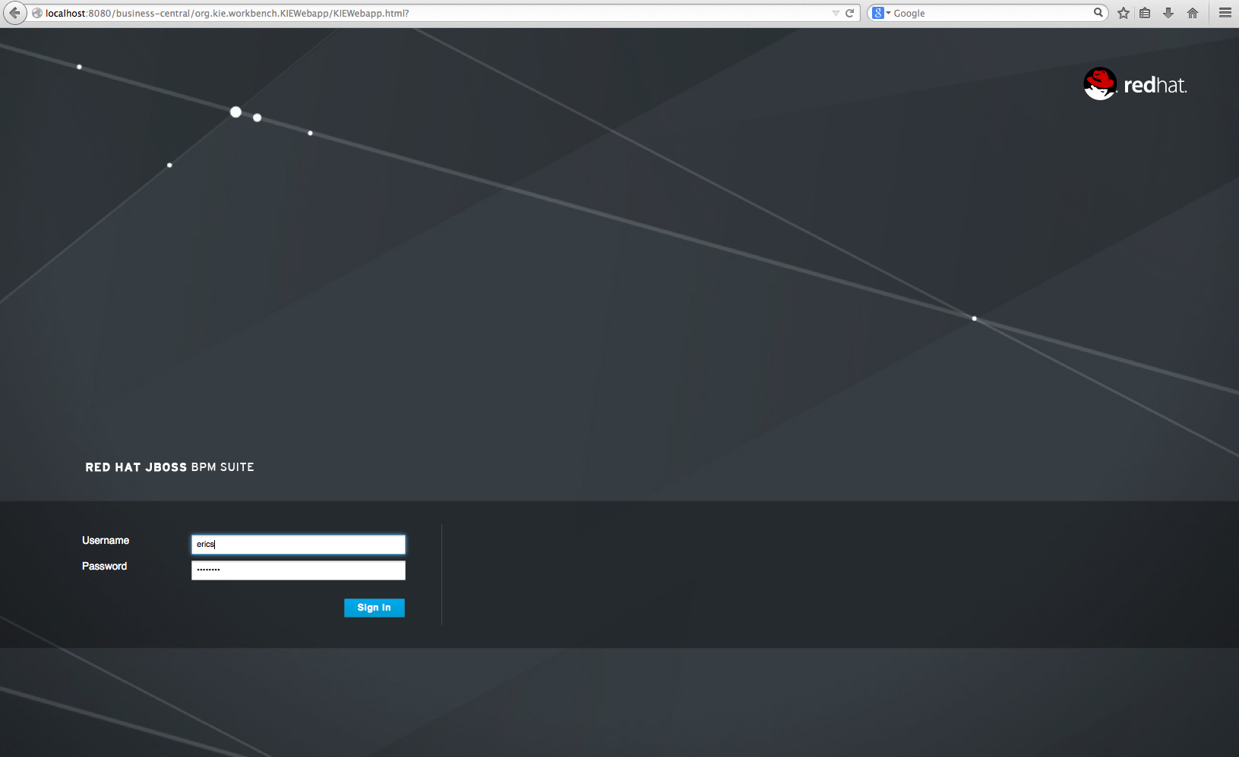

Administration Perspective
To view this perspective once you login you open by clicking on Authoring → Administration.
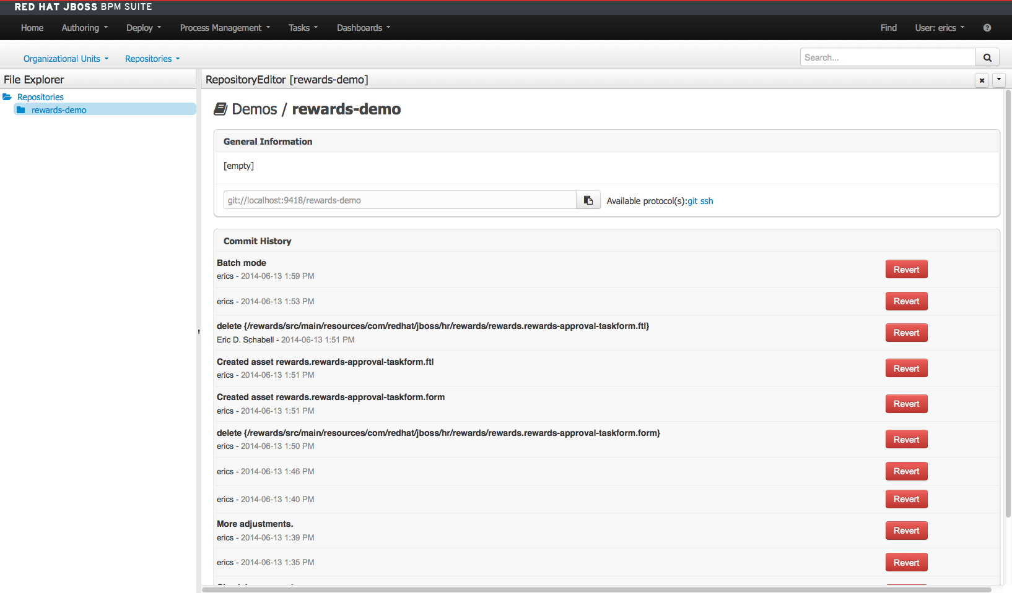

Project Authoring Perspective
This is the perspective that will display all the projects assets and allow you to edit or view them in each assets respective designer. This view is available by clicking Authoring → Project Authoring.
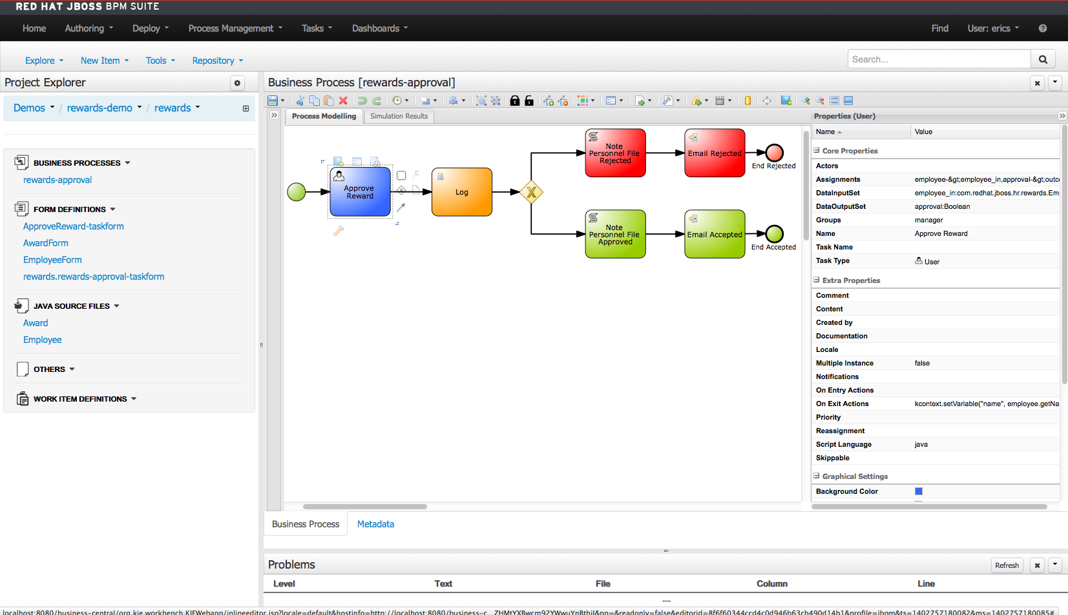

Web Process Designer
The web process designer is used to create BPMN2 processes and to review existing process assets. When you initially open this demo you should be presented with the process designer open.
- View process: Authoring → Project Authoring → Project Explorer (right panel) → Business Processes → rewards-approval and wait for web designer to appear.

Deploy project
To build the project for deployment:
- Build project: Authoring → Project Authoring → Tools → Project Editor → Build & Deploy (button), the project will be deployed and can be found under Process Management.
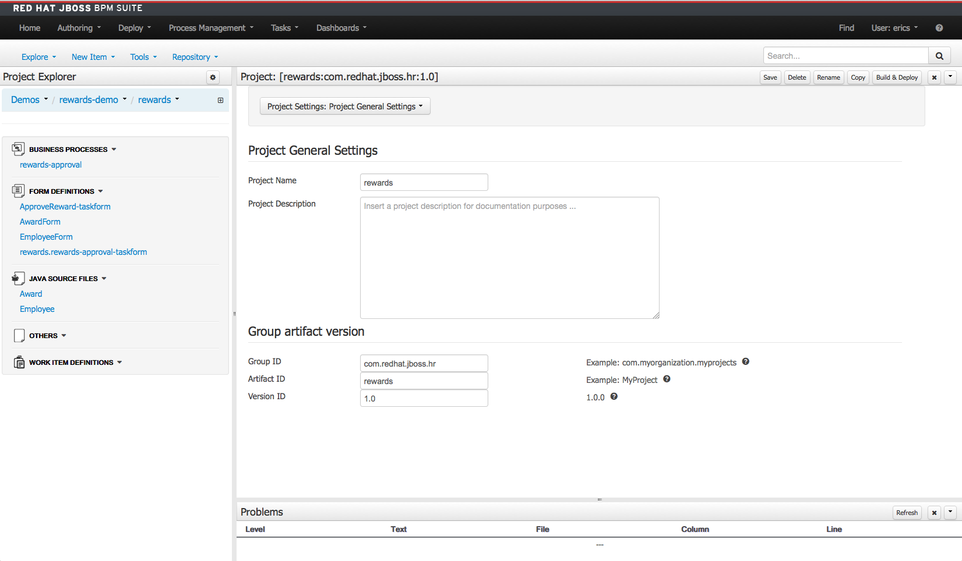

Data Modeler
To view the project domain model, open the data modeler:
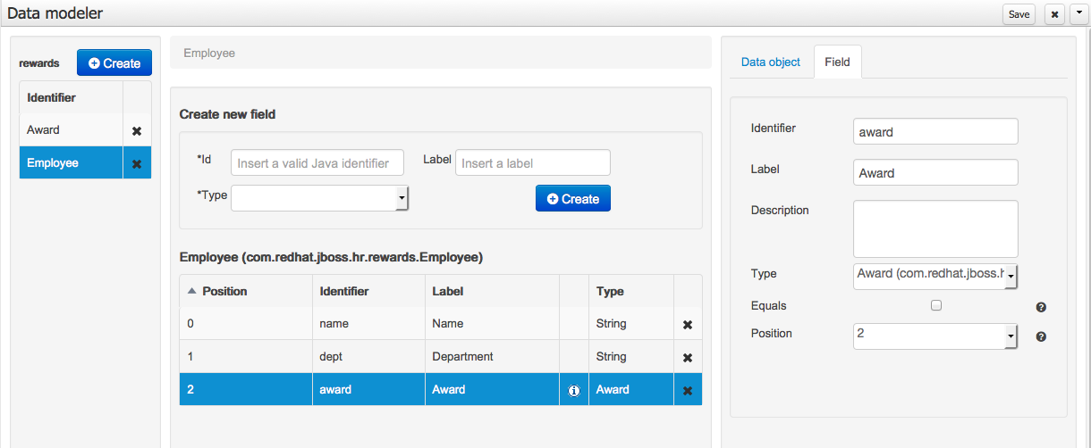
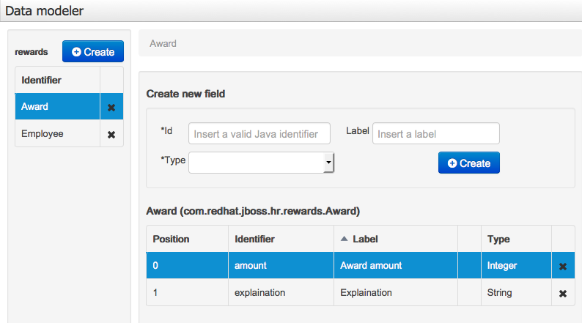
- Data modeler: Authoring → Project Authoring → Tools → Data Modeler, you can now view the data model.

If you are interested in viewing the source files which are Java objects generated by this modeler, click on the Java Source Files → Award or Java Source Files → Employee.

Form Modeler
Once the process was fully designed, the forms needed for user input to start the process and allow the approval task to be completed were generated using the process designer. These were modified by using the Form Modeler.
To view the forms found in this project, click on them to open the form modeler:
- Form modeler: Authoring → Project Authoring → Form Definitions → {rewards.rewards-approval-taskform|ApprovalReward-taskform|AwardForm|EmployeeForm}, you can now view the selected form.
  - Rewards.rewards-approval-taskform – the form used to submit data when starting a new process, always generated with the project name and the process id.
  - ApprovalReward-taskform – the form used for the Approval Reward user task.
  - AwardForm – a sub-form created to encompass the embedding of an Award object into an employee form.
  - EmployeeForm – a sub-from to create an employee with the award form embedded. This is submitted to the process in the Rewards.rewards-approval-taskform.

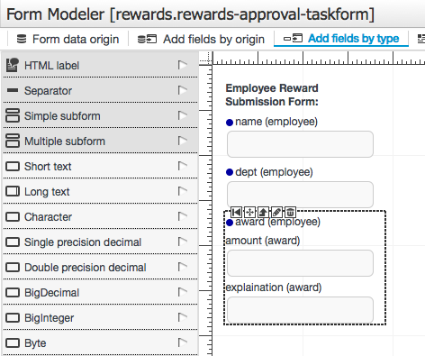

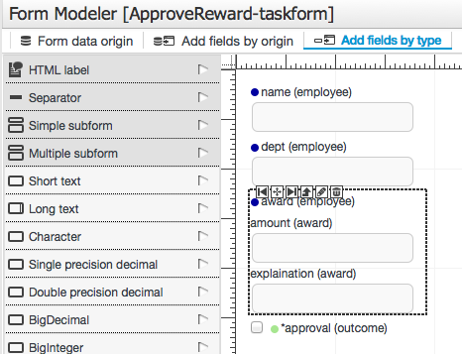

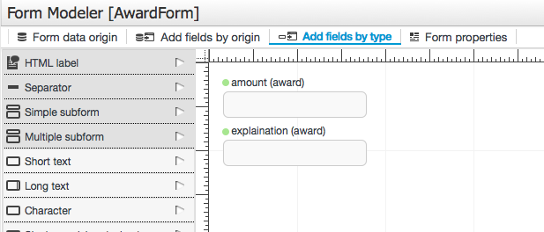
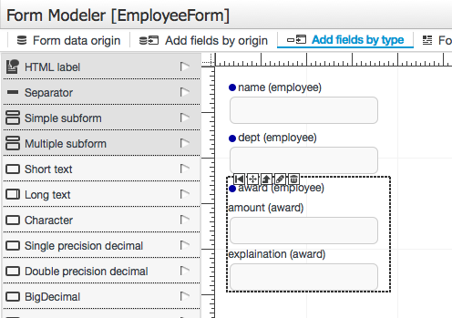

Running the demo
To run the project demo you have already read the above sections in this manual so you are logged into the JBoss BPM Suite dashboard and have viewed the project artifacts. You have also seen how to build and deploy this project.
To build the project for deployment:
- Build project: Authoring → Project Authoring → Tools → Project Editor → Build & Deploy (button), the project will be deployed and can be found under Process Management.
- Start an instance of the process: Process Management → Process Definitions where you should now see the rewards-approval process definition deployed.
- Click on the magnifying glass icon on the right to view the details of the process definition.
- You can start a new process instance by clicking on the New Instance button.
- The initial form will pop up and ask for information about the rewards submission, submit for example a name (string), a department that the employee works for (string), an amount for the reward (integer), and an explanation for the reward (string).
- Submit the form to start the process.
- You will be provided a look at the Process Instance window showing the process has started and is waiting in the Approve Reward.
- To view the task, claim, and complete it you will need to open the Tasks → Tasks List view at the top menu bar.
- You will see the entry Approve Reward with an unlocked lock icon and magnifying glass icon on the right. If not, make sure you are logged in with a user that has the manager role, which you can check by opening the User menu in the top right of the dashboard.
- Claim the task by clicking on the open unlocked lock icon which will open up the Details of the task and add a closed lock icon, a check-mark icon, and a magnifying glass icon are now available in the Actions section of the task.
- You can start working on the task by clicking on the check box icon, which opens the Approve Reward task form, you can view but not edit the data (read-only) in this form, but are responsible to approve (check the box) or reject (leave the check box empty) the award and Complete the task.
- The Tasks List you are viewing will not be empty as the task has completed and been removed from the view.
- Go back to Process Management → Process Instances. Note that the Active view will no longer contain the process instance we were working with as it has completed.
- Select Completed to find our completed rewards-approval process, where we can view the details by clicking on the magnifying glass icon.
- The Instance Details show the path taken by this instance and other details like process variables and process model can be found under Views → Process Variables and Views → Process Model.
- Finally, you can view the Business Activity Monitoring (BAM) reports on our process and task execution by opening Dashboards → Process & Task Dashboard. Feel free to explore the provided data as you see fit.

Workshop – building the demo
If you are interested in building the demo yourself, feel free to follow the workshop provided in the docs directory of this project. It is a web based workshop you can follow via your browser, just open the bpms-rewards-demo/docs/bpmsuite-rewards-workshop/index.html file.
